**[if](https://docs.djangoproject.com/en/4.0/ref/templates/builtins/" \l "std-templatetag-if), elif, and else**

Evaluates a variable, and if that variable is “true” the contents of the block are displayed:

|  |  |  |
| --- | --- | --- |
| **Syntax-1**  **{% if condition %}**  **Block**  **{% endif %}** | **Syntax-2**  **{% if condition %}**  **Block**  **{% else %}**  **Block**  **{%endif%}** | **Syntax-3**  **{% if condition %}**  **Block**  **{% elif condition %}**  **Block**  **{% else %}**  **Block**  **{% endif %}** |

**Views.py**

from django.shortcuts import render

# Create your views here.

def display(request):

    dict1={'n':5}

    resp=render(request,"welcome.html",context=dict1)

    return resp

welcome.html

<html>

<body>

    <h1> Welcome to Templates </h1>

    {% if n >= 5 %}

    <h2> Hello {{n}}</h2>

    {%endif%}

</body>

</html>

**Static files**

Aside from the HTML generated by the server, web applications generally need to serve additional files — such as images, JavaScript, or CSS — necessary to render the complete web page. In Django, we refer to these files as “static files”.

Websites generally need to serve additional files such as images, JavaScript, or CSS. In Django, we refer to these files as “static files”. Django provides **[django.contrib.staticfiles](https://docs.djangoproject.com/en/4.0/ref/contrib/staticfiles/" \l "module-django.contrib.staticfiles" \o "django.contrib.staticfiles: An app for handling static files.)** to help you manage them.

1. Create project

django-admin startproject staticproject

1. Create application

python manage.py startapp app1

1. Create folder inside project with name static

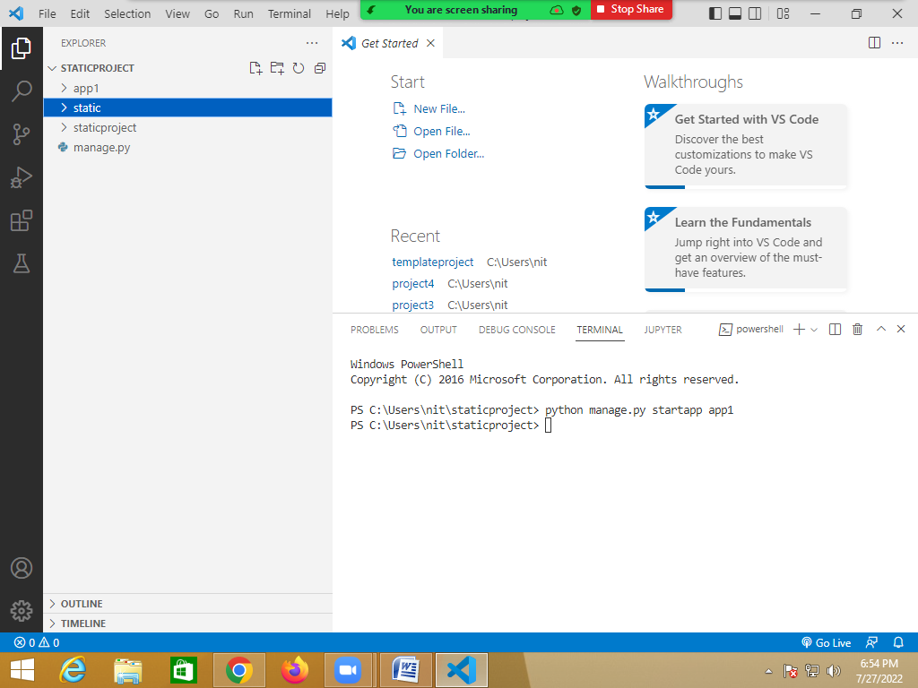

1. Configure this static folder inside project configuration file called settings.py

STATICFILES_DIRS = [BASE_DIR,"static",]

STATIC_URL = 'static/'

1. Create template folder inside project and configure inside **settings.py**

**import os.path**

TEMPLATES_DIR=os.path.join(BASE_DIR,"templates")

TEMPLATES = [

    {

        'BACKEND': 'django.template.backends.django.DjangoTemplates',

        'DIRS': [TEMPLATES_DIR],

1. Create template test.html inside templates folder

{% load static %}

<html>

<body>

<h1> This loading Images </h1>

<img src="{% static '/images/django.png' %}"/>

</body>

</html>

1. Views.py

from django.shortcuts import render

# Create your views here.

def display_image(request):

    res=render(request,"test.html")

    return res

1. Urls.py

from django.contrib import admin

from django.urls import path

from app1 import views

urlpatterns = [

    path('admin/', admin.site.urls),

    path('test/',views.display_image),

]

1. Settings.py

INSTALLED_APPS = [

    'django.contrib.admin',

    'django.contrib.auth',

    'django.contrib.contenttypes',

    'django.contrib.sessions',

    'django.contrib.messages',

    'django.contrib.staticfiles',

    'app1',

]

**{%load STATIC_URL%}**

This tag is used for loading folder or making folder available to template

{%static ‘path’%}

This tag is used for using static files within template